GOOD DESIGN

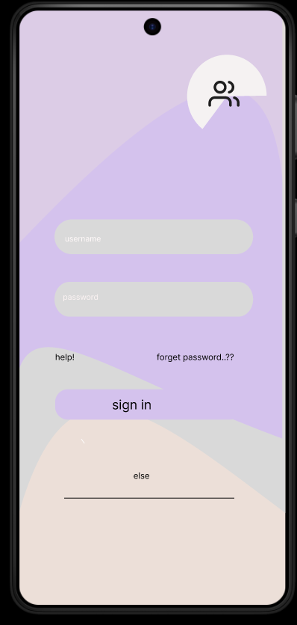

This design incorporates a modern and aesthetically pleasing layout, making it an excellent choice for a login interface. The soft pastel color scheme creates a visually appealing and calming user experience while maintaining sufficient contrast for readability. The rounded input fields for the username and password are well-placed, ensuring a smooth and comfortable interaction. Additionally, the use of curved shapes in the background adds a unique and stylish touch, making the design more engaging and less rigid compared to traditional login screens.

The placement of text elements is thoughtfully done, ensuring that users can easily find the necessary options without overwhelming them. The "sign in" button is prominent and stands out against the background, making it easy to locate and click. Furthermore, the inclusion of "help!" and "forget password...??" options ensures that users have access to assistance if needed. The subtle yet effective use of iconography, such as the user icon in the top corner, reinforces the purpose of the screen without adding unnecessary clutter.

Despite its artistic approach, the design still maintains functionality, providing a balance between aesthetics and usability. The well-spaced elements prevent accidental clicks, and the minimalistic approach enhances clarity, making it a user-friendly experience. This login screen successfully merges creativity with practicality, resulting in a visually engaging yet functional design.

BAD DESIGN:

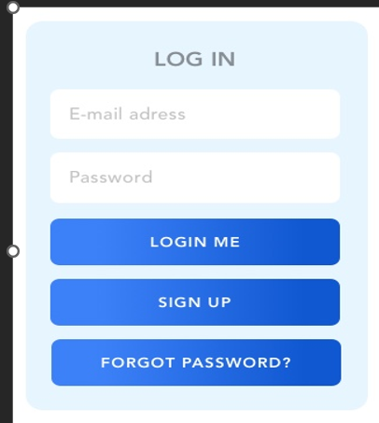

EXPLANATION FOR THIS BAD DESIGN:

This login design has several flaws that impact usability and accessibility. The most noticeable issue is the spelling mistake in "E-mail address," which should be corrected to "E-mail address" for professionalism and clarity. Additionally, the button text "LOGIN ME" is unnatural and should simply be "LOG IN" to align with standard terminology. The design also lacks a clear hierarchy, as the "SIGN UP" and "FORGOT PASSWORD?" buttons are styled too similarly to the primary action button, making it harder for users to differentiate between actions. Another problem is the use of placeholders instead of proper labels, which disappear when users start typing, potentially causing confusion about what information is required.

The contrast between the background and the text is weak, which can make readability difficult, especially for users with visual impairments. Moreover, the form does not provide a "Show Password" option, which would improve user experience by reducing login errors. There is also no real-time validation feedback, meaning users might only find out about errors after submitting the form rather than being guided as they type. The absence of social login options is another drawback, as many modern applications offer Google or Facebook login for convenience. Additionally, the buttons are placed too closely together, which could lead to accidental clicks, frustrating users. Finally, the colour scheme and text contrast should be improved to ensure accessibility standards are met, making the form more inclusive for all users.